Run a command on container’s start
Below docker compose file will run a specified command when container starts (starts a bash session in this case):
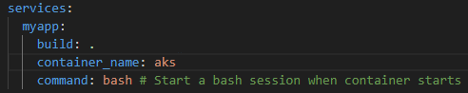

Get access to the container’s shell
Below docker compose file will allocate a pseudo TTY. It will make it possible to get access to the container’s shell from our terminal:
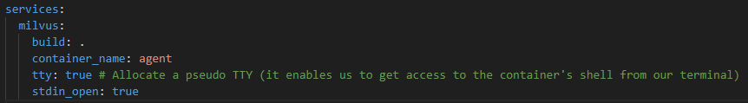
After we run such a container we can get access to its terminal by running this command:
- docker exec -it <container -name> bash

Map ports
We can specify how internal container’s ports are exposed to the host machine.
We specify it in a docker compose file like this:
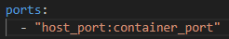
So we specify which port on the host correspond to which host in a container.
This is needed if we want to connect to a process running in a container from outside of a container.
If we have a process running in a container listening on the port given by the container_port, and we want to connect to it from outside of the container, we can connect to it using localhost:host_port.

Create a volume
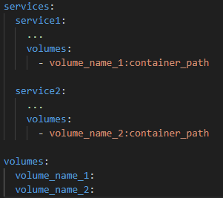

Mount a folder
We can mount a folder to a container so whenever we make change in this folder on the host, the same changes are reflected in the container.
It also works the other way around – changes made in the container are reflected on the host.
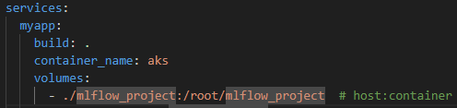

Run container in a background
Docker compose up -d

